Home Learning
Week beginning: 15th June 2020

Here are our learning topics for the week:
English: Listening and Speaking, Phonics, Making Predictions, Read and Draw
Maths: Money
Gaeilge: Ag Siopadóireacht
Whole-school event: Active Fortnight

Morning Meeting:
We hope you are enjoying the Morning Meeting as part of your daily routine. Try to start each day with this if you find it beneficial. Your child can choose to add some sentences/topics of their own. Have some fun with it!

Seesaw:
Please log in to the Seesaw app and try it out if you haven’t already done so. We have uploaded a variety of tasks for your child to try this week.

Monday, 15th:
1. English - Listening and Speaking: “What am I?”
The adult will give you some clues about an object. It is the child’s job to guess what it is! Check out these examples below. They have a food theme.

Once your child becomes familiar with the game, the roles can be reversed- your child can give clues about an object and the adult can guess what it is. Remember, try not to give it away!
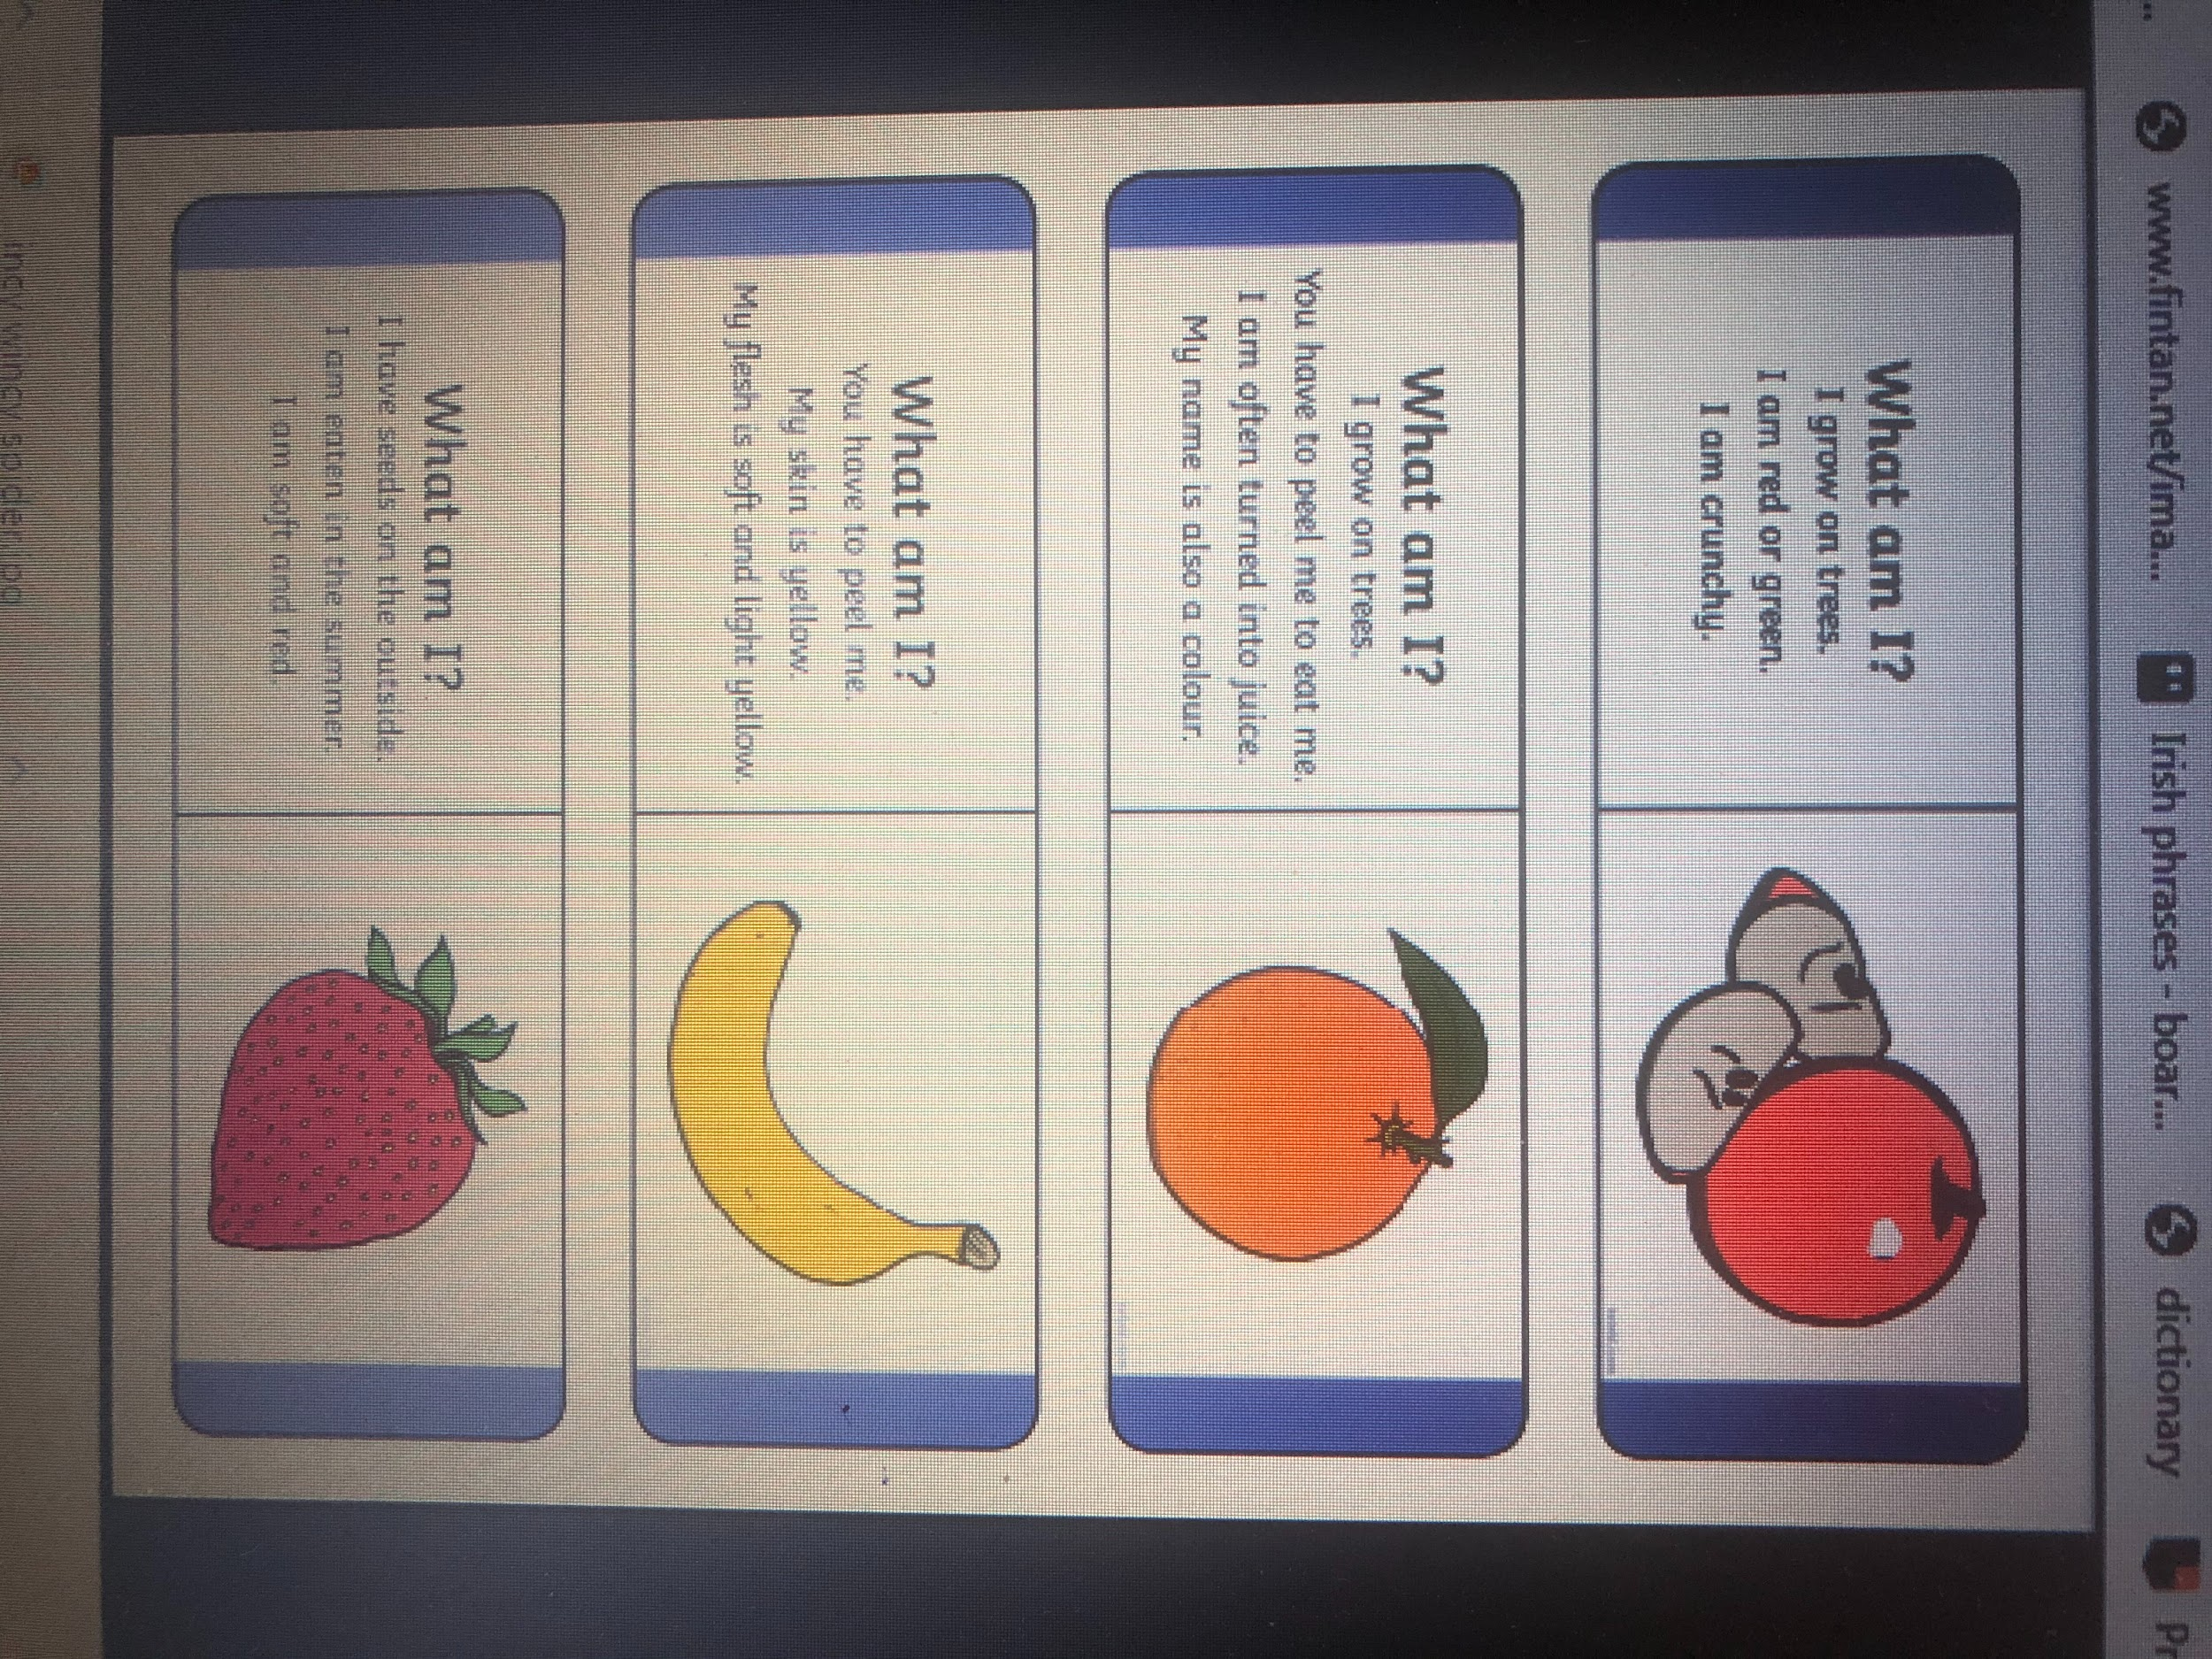
2. Maths-Money: Please refer to Seesaw for today’s activity.

3. Goals for Next Year: Please refer to Seesaw for today’s activity.

4. Active Fortnight: Go back to the website and click the link!

Tuesday, 16th:
1. English - sh/ch/th: Go to Seesaw for today’s activity.

2. Maths- Money: Go to Seesaw for today’s activity.

3. Celebration of Work: Go to Seesaw for today’s activity.

4. Active Fortnight: Go back to the website and click the link!

Wednesday, 17th:
1. English - sh/th/ch: Please refer to Seesaw for today’s activity.

2. Maths- Money: Please go to Seesaw for today’s activity.

3. Gaeilge: Our topic for the month is Ag Siopadóireacht (Shopping).
Please refer to the website for a PowerPoint presentation containing the relevant vocabulary for Wednesday, Thursday and Friday. This learning is spread out over three days. Click on the speaker icon to hear recordings of the vocabulary pronounced correctly. There are also some listening activities included. Below is a table of the new vocabulary for the week.

siopa éadaí  (clothes shop) | siopa bréagán  (toy shop)
teach  (house) | rothar  (bike)
capall  (horse) | buachaill bó  (cowboy)

4. Active Fortnight: Go back to the website and click the link!

Thursday, 18th:
1. English -Making Predictions:
Please refer to the website to listen to the story ‘Monkey Puzzle’ being read aloud. Last week, you tried to make predictions about what the story might be about. Were you right? Discuss the similarities and difference between the predictions you made last week and what happened in the story.

2. Maths- Money: Please go to Seesaw for today’s activity.

3. Gaeilge: Please refer to Wednesday’s activity above.

4. Active Fortnight: Go back to the website and click the link!

Friday, 19th:
1. English- Read and Draw: Please refer to Seesaw for today’s activity.

2. Maths- Money: Set up a shop at home again. You can use play food if you have it or empty items from the kitchen. You and your child could even draw items for the shop. Price the items from 1cent to 5cent. You will need lots of 1cent, 2cent and 5cent coins. Take turns on being the shopkeeper/customer.

3. Gaeilge: Please refer to Wednesday’s activity above. Check out the bonus activity on Seesaw today!

4. Active Fortnight: Go back to the website and click the link!

Bonus activity: Don’t forget that Caitríona will be hosting a school assembly today! Check your emails for details.

