Home Learning
Week beginning: 5th May 2020

Here are our learning topics for the week:
English: Phonics
Maths: Using your Maths Eyes
Gaeilge: An Teilifís (The Television)
Music: Performing- song singing
Whole-school event: Well-being Fortnight

*This week, we are learning about performing-song singing. There will be songs for your child to learn and perform as Gaeilge (in Irish) but they can learn and perform songs of their choice too!

At the end of the week, the children will be invited to perform a song (Irish or their choice), record it and send it to us. Perhaps your child can think about a song they would like to perform. They can rehearse it at a time that suits them so they are prepared to sing it with confidence! Break a leg!

Please log in to the Seesaw app and try it out - we are asking you to send us one piece of work each week. This week, you could try sending it to us using Seesaw. If that’s not easy for you, not to worry. We hope to iron out any difficulties over the coming weeks.

Monday:
Bank Holiday - Relax and enjoy some time with your family.
Check out the Well-being Fortnight event page!

Tuesday:
1. Maths- Using your Maths Eyes: Maths is all around us. We can see it at home, in school and even when we go outside. Below you will find a picture of a shed. Use your maths eyes to see how many shapes you can find. Can you count the glass windows? You could try to make your own picture using lots of different shapes. We have included some examples of shape pictures below but you can try to think of your own if you want.
2. Gaeilge: Can you remember how to count to ten as Gaeilge? (In Irish)
Please refer to the website for counting video. Say the numbers aloud with Ruth or repeat them after her. Perhaps you could count using your fingers? Try counting objects from your home as Gaeilge too! (Lego, spoons, crayons, blocks etc.)
Below is a table of numbers 1-10

- A haon | 6. A sé
- A dó | 7. A seacht
- A trí | 8. A hocht
- A ceathair | 9. A naoi
- A cúig | 10. A deich
Please refer to the website to listen to the songs we will be learning in Gaeilge and Music:
- Listen and sing along to the song “Tá Teidí sa Seomra Suí”

3. Music: This week we are learning about song singing. We are going to link this learning with the Gaeilge songs about An Teilifís (The Television) that we will be learning this month.

Let’s take a moment to remind ourselves of how to sing and breathe our best while performing-
- Sit up straight with shoulders back or stand up straight. Good posture helps us to take a deep, full breath before singing.
- Like our body, our voice needs to warm up before we exercise it. Please refer to our website for a suggested warm up video or search for one of your choice. The suggested warm up video is 9 minutes long. You can break this down into 2-3 minutes per day, or you can warm up for 9 minutes each day.
- Your singing voice should sound different to your speaking voice
- Sing from your tummy- it shouldn’t hurt your throat
- Have fun!

Song: “Tá Teidí sa Seomra Suí”
- Once you have warmed up your voice, prepare to play the song from your Gaeilge learning, “Tá Teidí sa Seomra Suí”.
- Check your posture.
- When you are ready, play the song and sing along to it.
- You can do this as many times as you wish.
- Perhaps you could even try it without the music!

4. Well-being Fortnight: Go to the Well-being Fortnight page for today’s activity!

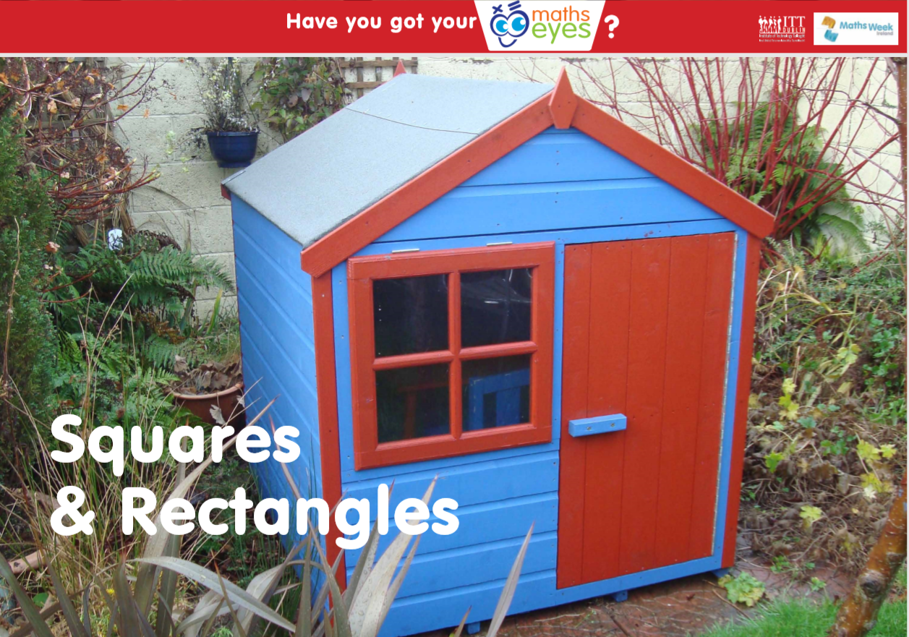
Here are some examples of shape pictures but you can make your own if you want.
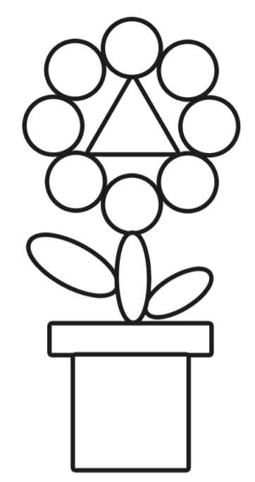
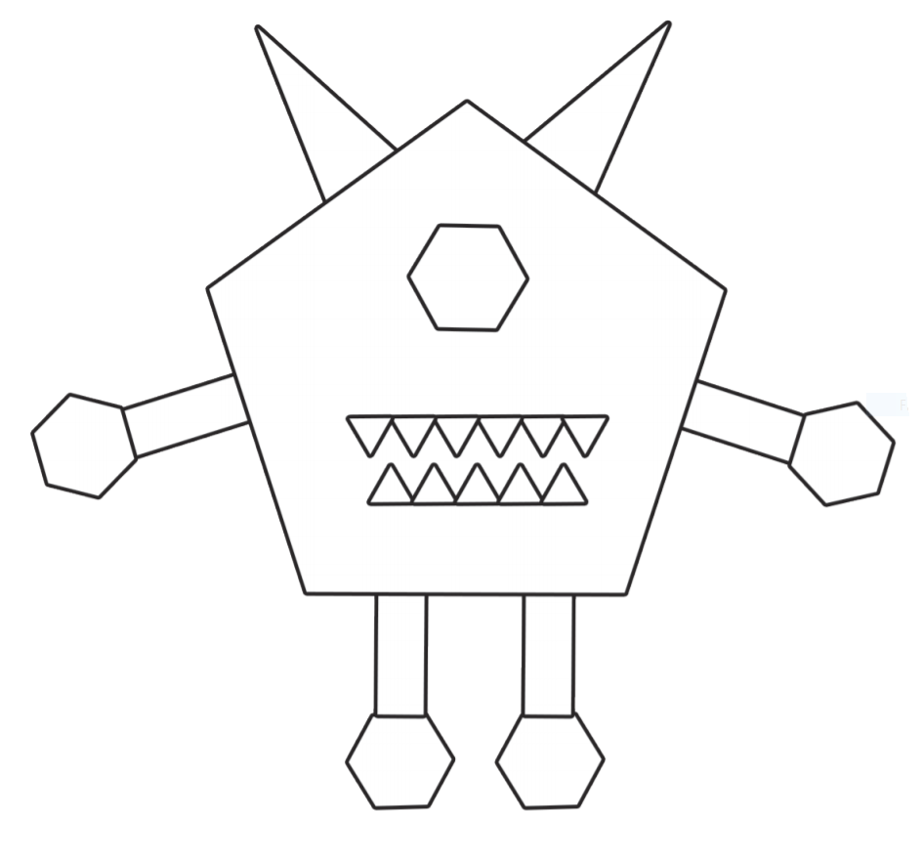
Wednesday:
1. English - ‘qu’ sound: Revise the sound and the action. Please go back to our website to see a PowerPoint based on the ‘qu’ sound. Identify words that begin with or contain the ‘qu’ sound. The children can try to read the following words: quit, queen, quiz, quid, quilt. Go back to our website to see a link to an activity online based on the ‘qu’ sound. We have included a worksheet below based on the ‘qu’ sound.
2. Maths- Using your Maths Eyes: Go to Seesaw for today’s Maths task.
3. Gaeilge: What colours can you remember as Gaeilge?
Please refer to the website for a video containing colours. Say them aloud with Laura or repeat them after her. Can you find these colours in your home and name them in Irish?

Below is a table containing the colours we have learned at school-

Glas  (Green) | Corcra  (Purple)
Dearg  (Red) | Oráiste  (Orange)
Buí  (Yellow) | Dubh  (Black)
Gorm  (Blue) | Bán  (White)

Please refer to the website to listen to the songs we will be learning in Gaeilge and Music:
- Listen and sing along to yesterday’s song “Tá Teidí sa Seomra Suí”
- Listen to the song “Tá Feirm ag an bhFeirmeoir” (The Farmer has a Farm). Do you recognise this tune? Try to sing along!

4. Well-being Fortnight: Go to the Well-being Fortnight page for today’s activity!

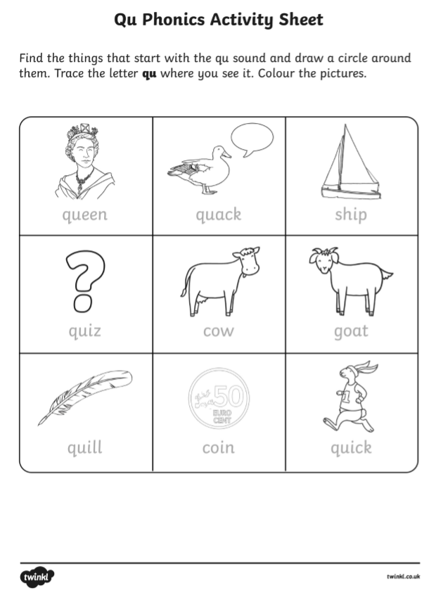Thursday:
1. English - ‘ou’ sound: Revise the sound and the action. Please go back to our website to see a PowerPoint based on the ‘ou’ sound. Identify words that begin with or contain the ‘ou’ sound. The children can try to read the following words: ouch, out, loud, shout. We have included a worksheet below based on the ‘ou’ sound. Keep an eye out for ‘ou’ words and try to read the sentences on the worksheet.
2. Maths- Using your Maths Eyes: You will find a shape picture below. Can you count all the different shapes you can see? How many squares, circles and rectangles can you find? You can print the worksheet out or just look at the picture.
3. Gaeilge: The new topic for this month is An Teilifís (The Television).
Please refer to the website for a PowerPoint presentation containing the relevant vocabulary for Thursday and Friday. This learning is spread out over two days. Click on the speaker icon to hear recordings of the vocabulary pronounced correctly. On the PowerPoint, you will find some listening activities. There is also a little poem for the children’s enjoyment.

Below is a table of the relevant vocabulary on this topic for the week. Perhaps you could find some of these items/objects/pictures in your home and name them in Irish? We will be adding to this vocabulary over the coming weeks.
An Teilifís  (The Television) | Tíogar  (Tiger)
An raidió  (The radio) | Leon  (lion)
An solas  (The light) | Cangarú  (Kangaroo)
Sorcas  (Circus) | Moncaí  (Monkey)
Please refer to the website to listen to the songs we will be learning in Gaeilge and Music:
- Listen and sing along to the song “Tá Teidí sa Seomra Suí”
- Listen and sing along to the song “Tá Feirm ag an bhFeirmeoir” (The Farmer has a Farm). Do you recognise this tune? Try to sing along!
4. Well-being Fortnight: Go to the Well-being Fortnight page for today’s activity

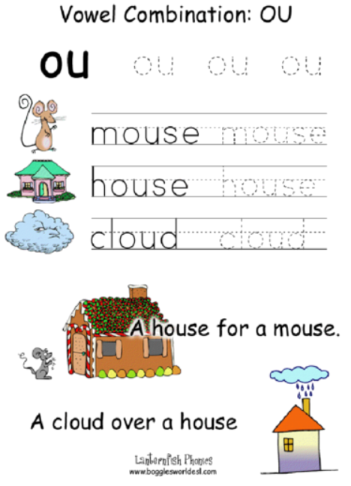

How Many Shapes Do You See?
Count the shapes and write the numbers below.

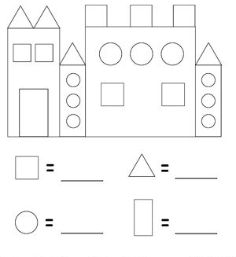

Friday:
1. English - en word family: Think of some words that belong in the ‘en’ word family (hen, pen, Ben, men, etc.). Your child can try to write a list of -en words. There is a worksheet below to practise -en words.
2. Gaeilge: Please refer to Thursday’s activity above.
3. Music: You have been performing songs about An Teilifís this week. You may also have been learning and performing a song(s) of your choice. Perform them again, creating a mini concert, with or without the music.
You can record a video of your performance and send it to us! You can do this through Seesaw if you wish. We would love to see you in action!
4. Well-being Fortnight: Go to the Well-being Fortnight page for today’s activity!

Bonus activity: Caitríona will be hosting an assembly for you on Zoom today. Try to join in if you can - she would love to see you! If you can’t make it, you can still practise your sign language skills with Caitríona here.

