Home Learning
Week beginning: 27th April 2020

*We are looking at dance this week for PE. For this, you are asked to play music. You might like to take some time in advance to choose suitable tracks. The children in both Junior Infant classes often have a ‘boogie’ in the classroom so you could ask the child to suggest a track or you could choose one. Happy Dancing!

Monday:
1. English - Oral Language: Morning Meeting. Discuss the days of the week (today is __, tomorrow will be __, yesterday was __) with your child. Discuss today’s date and today’s weather. An adult could write this on paper. Child and adult could read it together.
E.g. Morning Meeting
Today is Monday. Yesterday was Sunday. Tomorrow will be Tuesday. It is the 27th of April.
It is a ______ day.
2. Maths - Sets: Child draws a large circle on a page. On small pieces of paper, child writes numbers 0-5 and turns them over. Child picks a number randomly and must put that many items in the set (You could use Lego blocks, crayons, buttons, etc. ) To make it more difficult, you can use the numbers 0-10. We have included a worksheet below for you to practise making sets.
3. Geography: Name some of the jobs that people do in your community (shopkeeper, doctor, police officer, teacher, firefighter, vet, builder etc.). Record (write/draw) these jobs to create a mind map or brainstorm. Keep your mind map because you will need it for tomorrow’s activity. Choose one of these jobs (e.g. teacher) and discuss in detail how the people doing that job helps us. Discuss your own experiences/interactions with the people doing that job.
4. PE- Dance:
- Warm up your body using magic dust. As the dust falls on the different parts of your body, it wakes them up and they begin to move/dance.
- Choose music that you like (nothing too fast to begin with!) and march on the spot for eight beats. Count the beats out loud (1, 2, 3, 4, 5, 6, 7, 8).
- March forwards and backwards for eight beats, still counting out loud.
- Once you feel that your body is warm and ready for more exercise, choose a different piece of music. Your new focus is to create shapes with your body and to freeze in those shapes for eight beats.
- Explore all of the different shapes you can make (tall, wide, narrow, change direction). Hold one shape for eight beats and then change to create a new shape (1, 2, 3, 4, 5, 6, 7, change! 1, 2, 3, 4, 5, 6, 7, change! etc.)
- Try to explore different levels too (high, middle, low).
- Cool down your body by blowing the magic dust off your body parts. Once the dust is gone, your body parts start to slow down and stop. Take some time to settle your breathing by taking three deep breaths in and out.

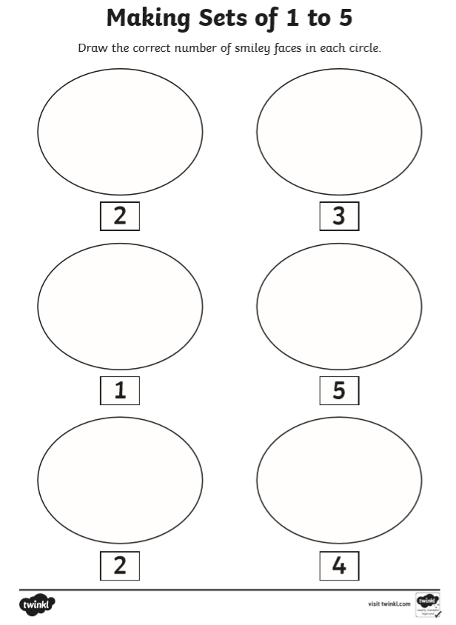
Tuesday:
1. English - ip word family: Think of some words that belong in the ‘ip’ word family (sip, nip, clip, zip, etc.). Your child can try to write a list of -ip words. There is a worksheet below to practise -ip words.
2. Maths- Zero: You will find a link to a song all about zero on our website. Discuss what zero means with your child. Brainstorm other words that mean the same thing as zero e.g. nothing, empty, none, etc.
3. Geography: Using the mind map you created yesterday, list the jobs that people do in your community. Just like you did yesterday, choose one of these jobs (e.g. shopkeeper) and discuss in detail how the people doing that job helps us. Discuss your own experiences/interactions with the people doing that job.
Below you will find some pictures of people who work in a community.
Look through the jobs in these pictures. Name each job and add it to your mind map if you haven’t already.
4. PE- Dance:
- Warm up your body using magic dust. As the dust falls on the different parts of your body, it wakes them up and they begin to move/dance.
- Choose music that you like (nothing too fast to begin with!) and march on the spot for eight beats. Count the beats out loud (1, 2, 3, 4, 5, 6, 7, 8).
- March forwards, backwards, to the left and to the right for eight beats, still counting out loud.
- Your focus today is on mirroring- copying the exact movements of someone else. Stand facing another person (sibling, parent, other family member). Choose which person is going to lead the movement first. Start to move parts of your body. If you are leading the movement first, your partner will copy you. If your partner is leading the movement first, then you will copy them. Take turns, remembering to create different shapes and levels with your body.
- Remember, move slowly, stay facing your partner and give your voice a break. Put on some music you love and have some fun with this!
- If you do not have a partner for this activity, that’s okay! You can stand in front of a mirror or window (something in which you can see your reflection) and move your body.
- Cool down your body by stretching high into the air and down to your toes, breath in as you reach high and out as you go to your toes. You can do this three times.

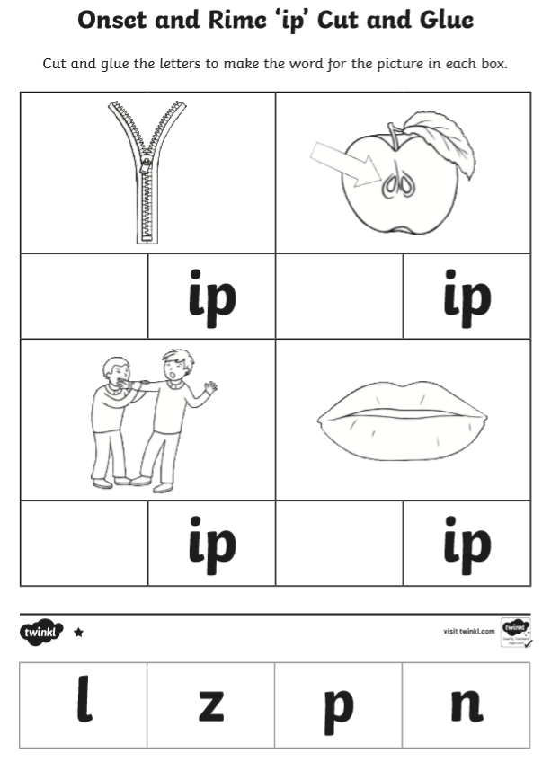
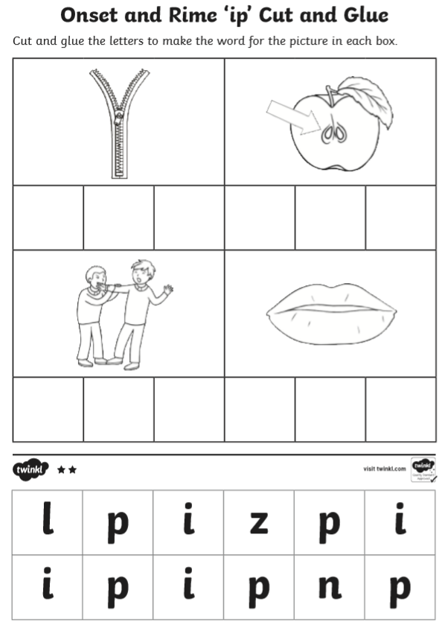
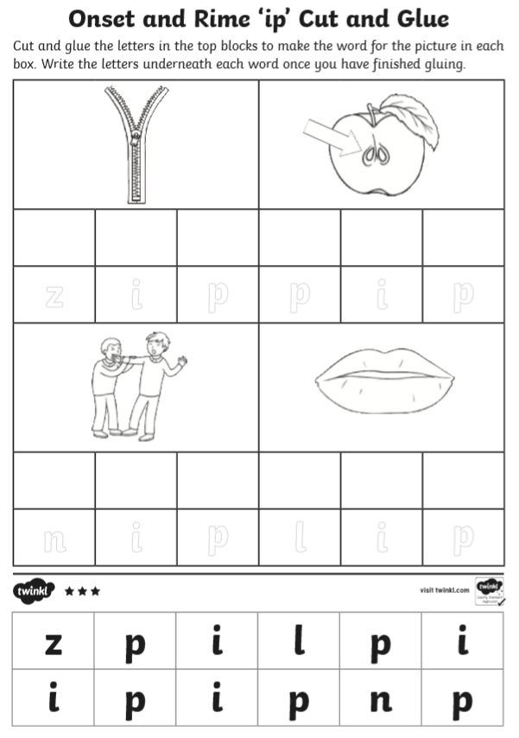
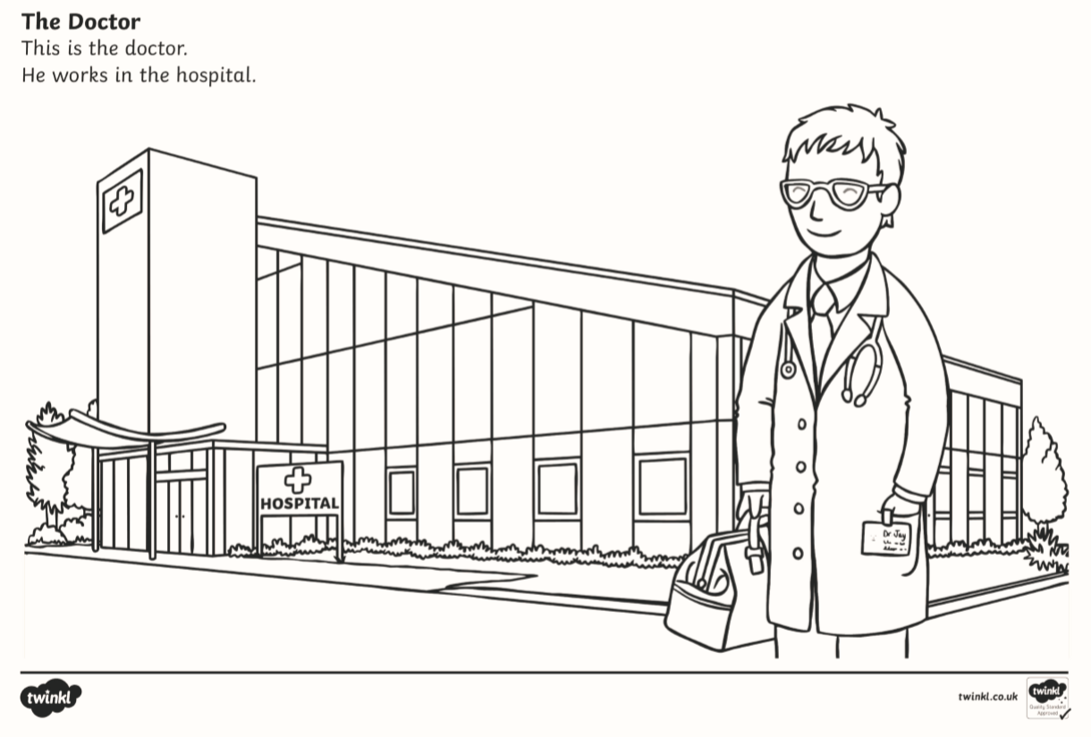

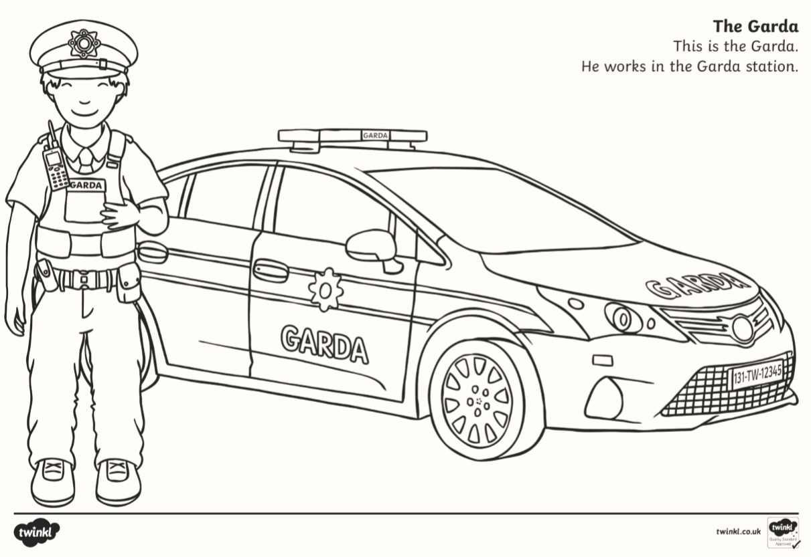
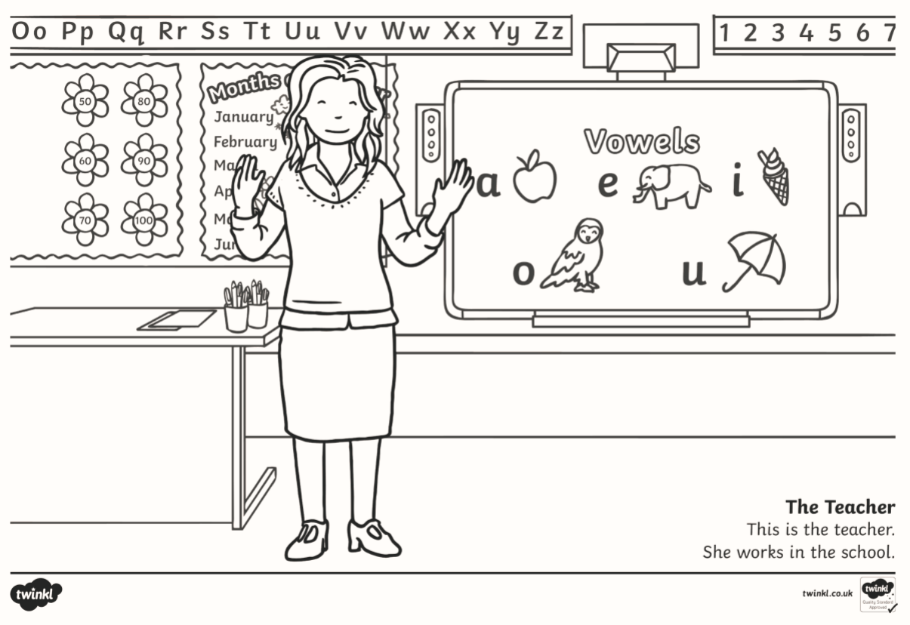
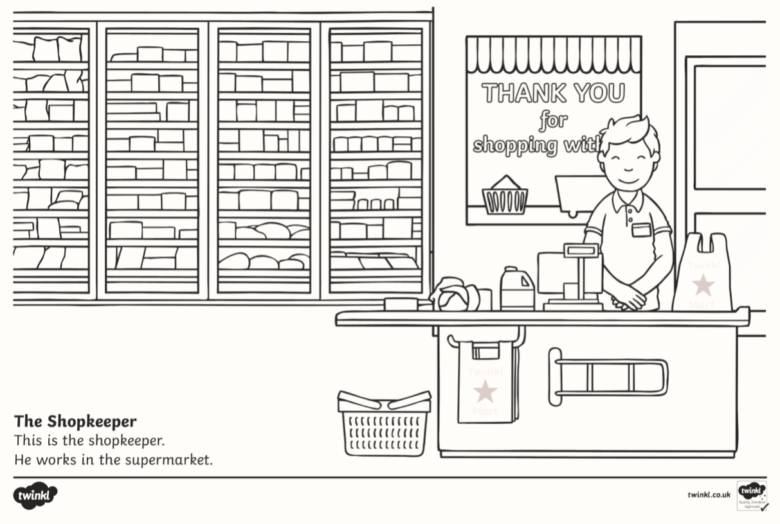
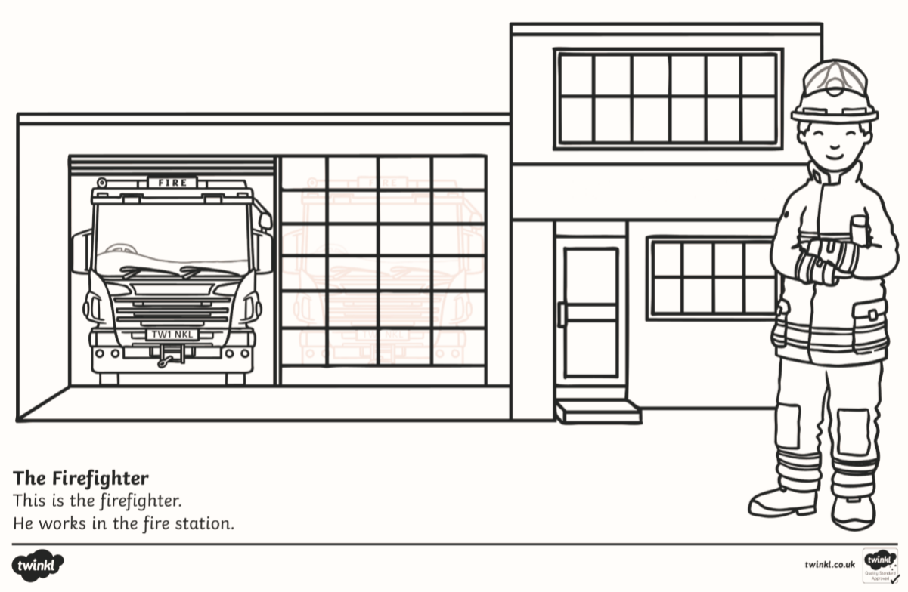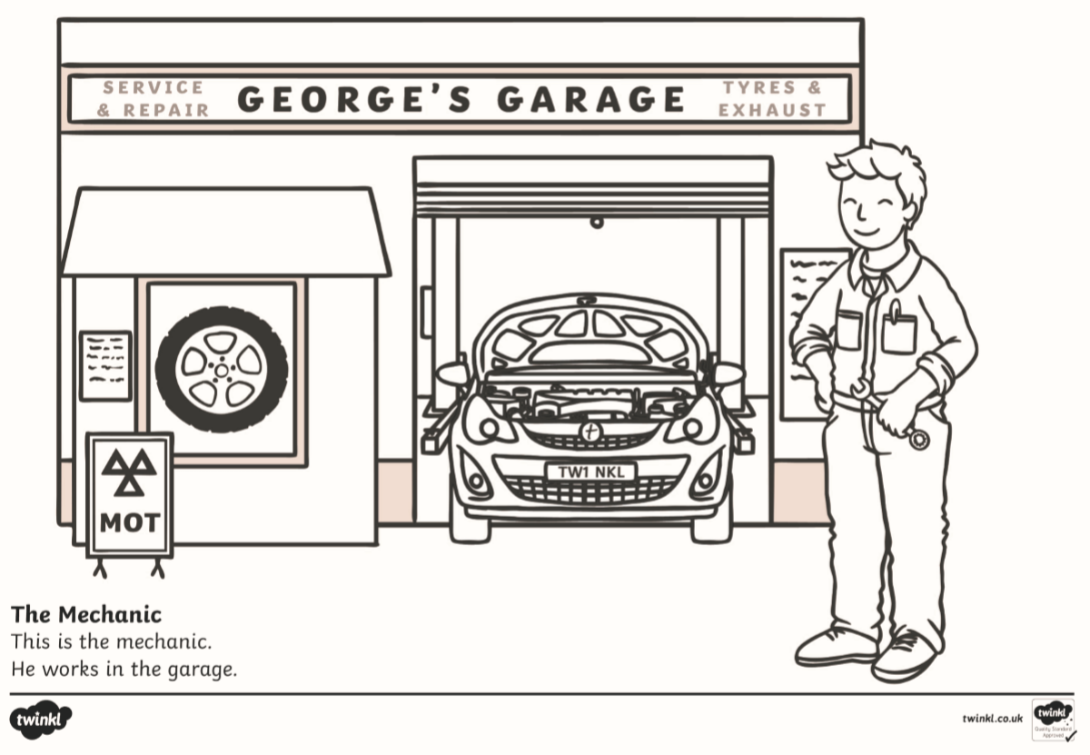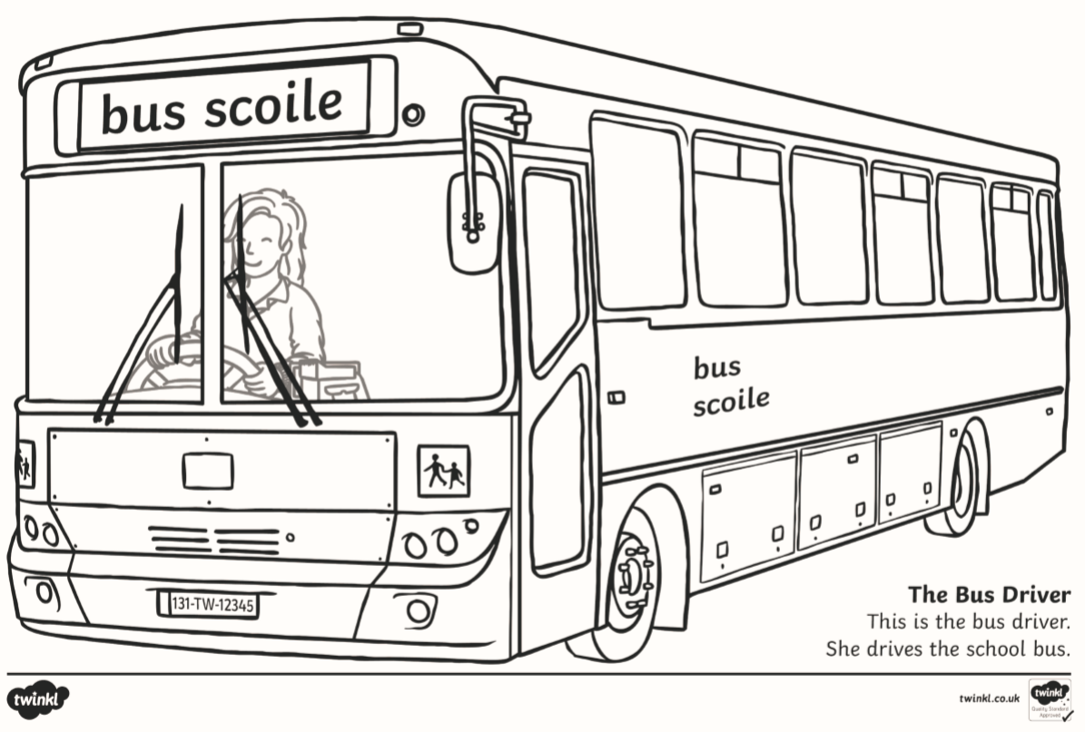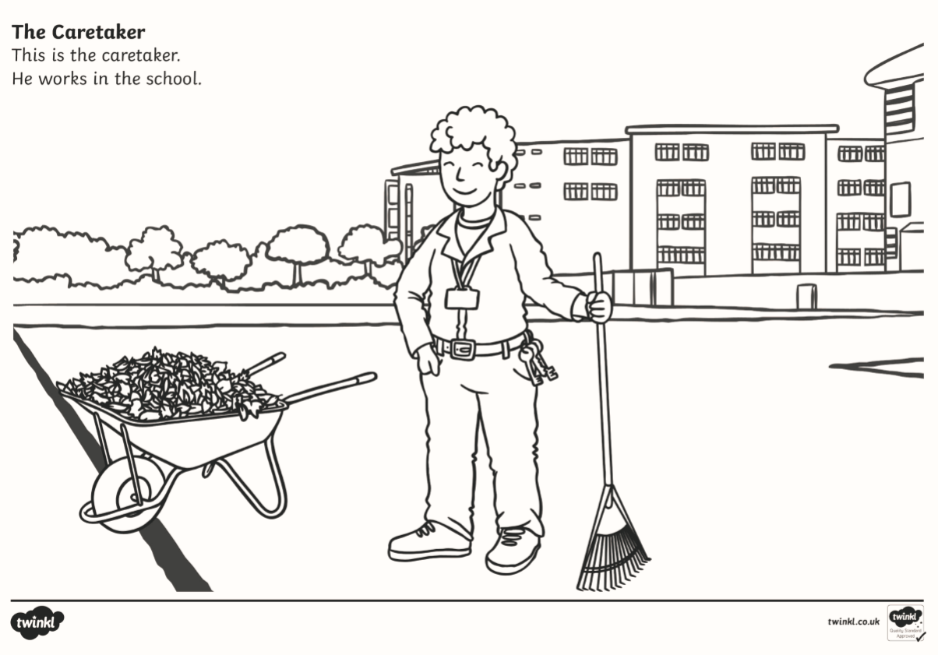

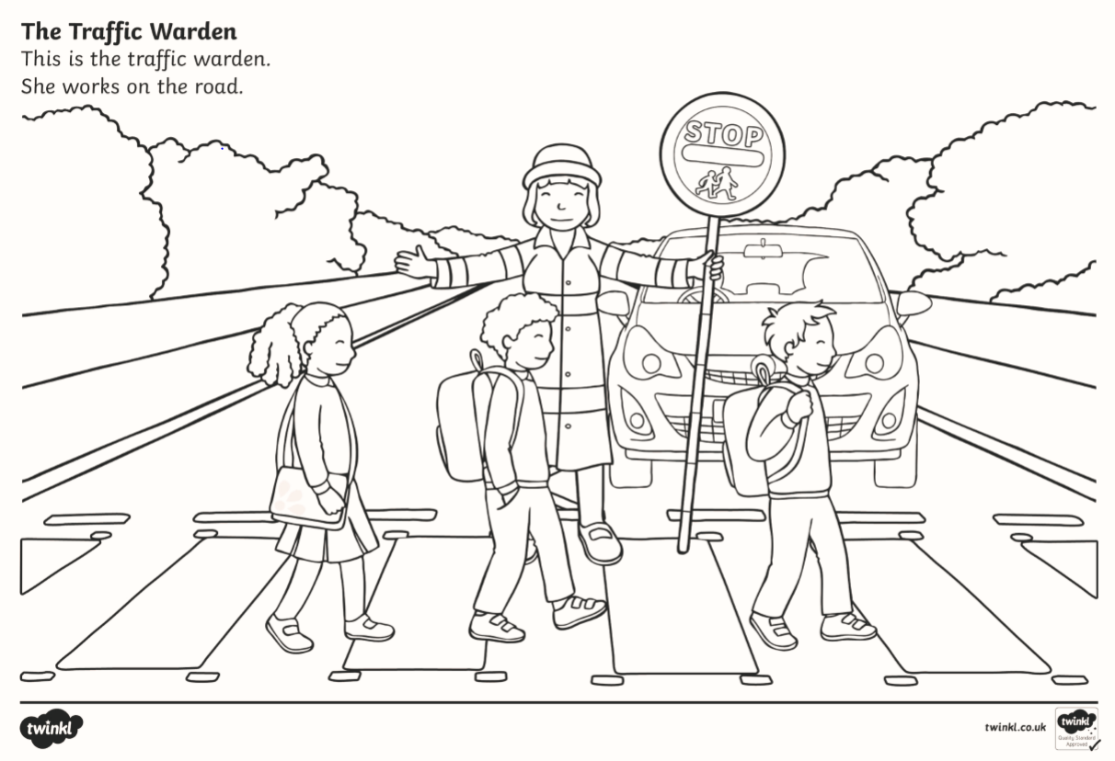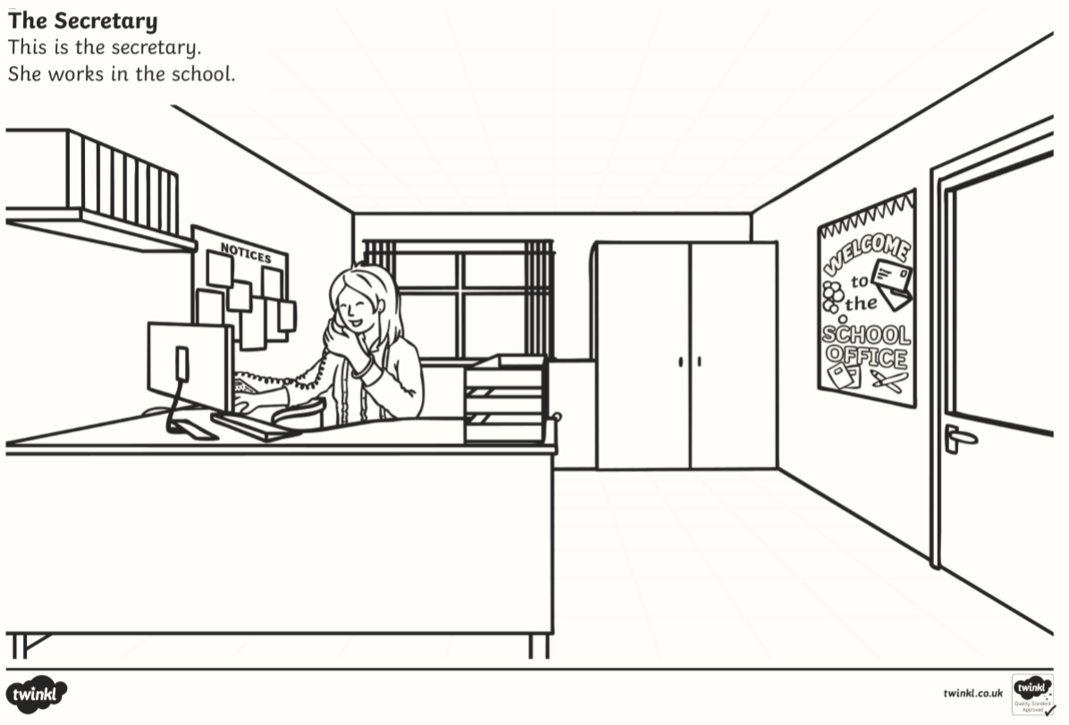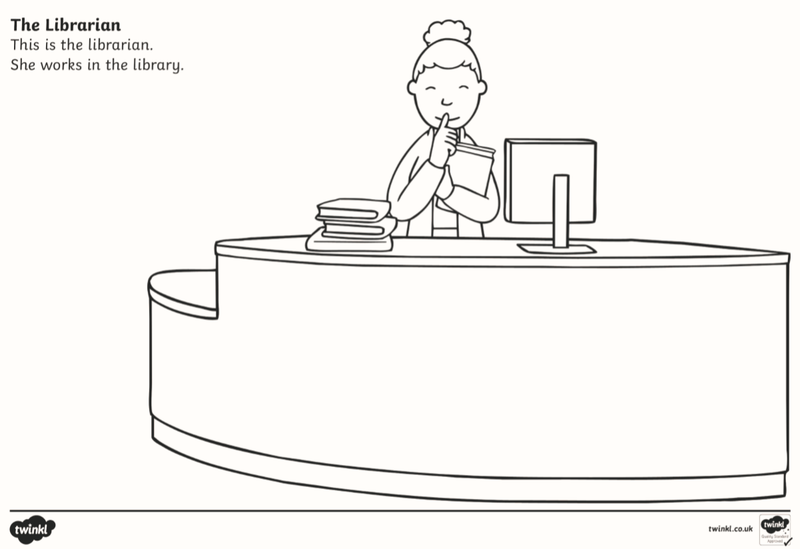

Wednesday:
1. English - ‘th’ sound: Revise the sound and the action. Please go back to our website to see a PowerPoint based on the ‘th’ sound. Identify words that begin with or contain the ‘th’ sound. The children can try to read the following words: thin, that, this. Go back to our website to see a link to an activity online based on the ‘th’ sound.
2. English - ip word family: Write out some of the -ip words you can remember. Please refer back to our website for a game to help you remember some -ip words.
3. Geography/Learn Together: Choose one of the pictures of people who work in the community from yesterday’s tasks. Look closely at it and discuss where that person works and the tools/equipment they need to do their job.
Discuss how that person can use their tools/equipment safely and responsibly. Below is a matching activity for you to complete.
4. Maths- Zero: Make a few cards with 0 written on them. Take a set of 8-10 bowls and arrange them in a line. In a few of the bowls put some blocks, sweets, or any other object and leave some bowls empty. The child needs to place the number 0 card in front of the bowls that are empty. Below there is a worksheet to help you learn all about the number zero.

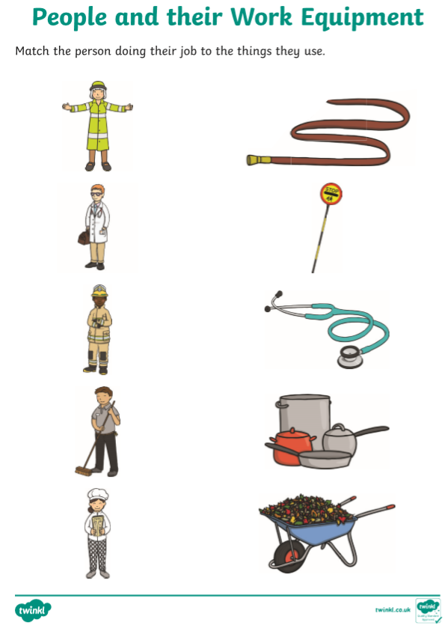
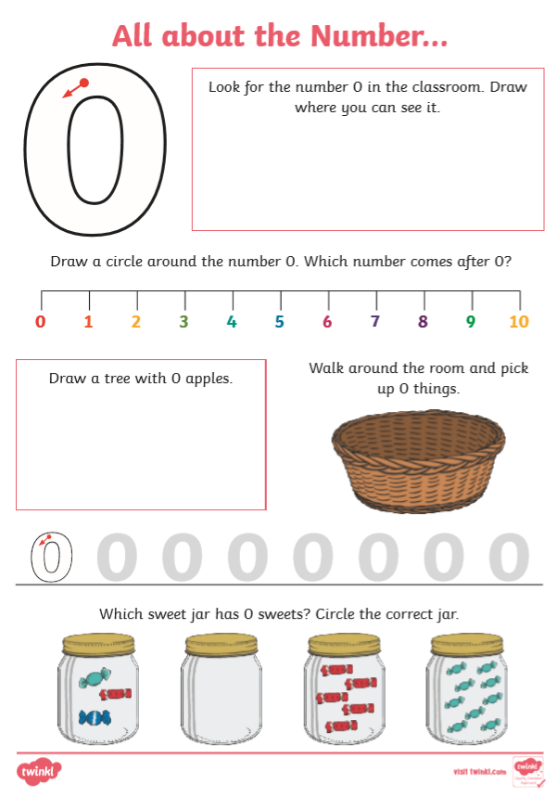Thursday:
1. English - ‘th’ sound: Revise the ‘th’ sound using yesterday’s activities. Do the cut and stick worksheet based on the ‘th’ sound below. Feel free to write the words if you don’t have any glue.
2. English - Reading: Go back to our website to see a read aloud of the story ‘Peepo’ that we have uploaded.
3. Maths -Number: Make your own number line or use the numberline you made last week. Ask questions based on the numberline using the words before/after and between. E.g. What number comes before 1? What number comes after 4? What number is between 3 and 5?
4. PE- Dance:
- Warm up your body with a game of musical statues. Remember to freeze when the music stops! Try to include some shapes and levels into your dancing.
- Your focus today is on creating dance to a piece of music. Choose music that you love. Try to bring marching for eight beats, shapes, levels, freezing for eight beats and mirroring into your dance. You can get really creative and have lots of fun with this! You can repeat movements throughout the dance too.
- Take some time to practice and rehearse your dance. Invite people in your home to watch your performance. They will want to join in with you!
- Get everyone dancing! Practice performing the Cha Cha Slide. Please refer back to our website for a link to this song. Alternatively, you can search “cha cha slide” 0n YouTube. You can use this dance as an active break in the future.
- Cool down your body by stretching high into the air and down to your toes, breath in as you reach high and breathe out as you go to your toes. You can do this three times.

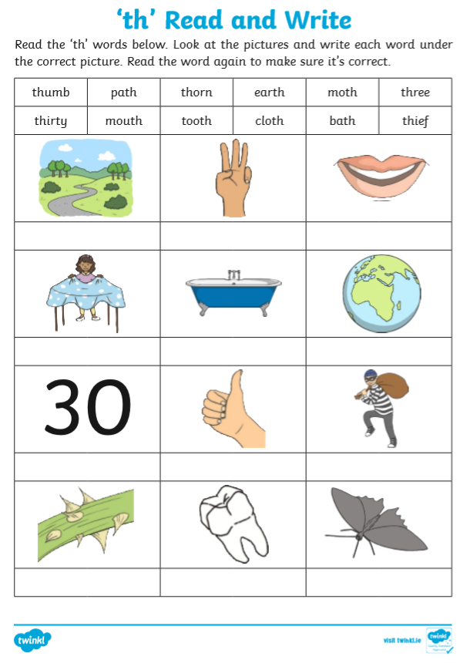Friday:
1. English: Practice letter formation of the letters c, o, a, d, g, q. All of these letters are made by starting with the letter ‘c’. We have included a video to help you remember the correct formation. You can practice on a sheet of paper or you will find a worksheet below.
2. Maths - Number: Please refer back to our website to play a game of Maths Hide and Seek!
3. Geography/Learn Together: Discuss the word “responsibility”. Discuss some of the responsibilities that people working in your community have when doing their job. Discuss a job that you might like to have in the community. Draw yourself doing this job or choose one of the pictures to colour.

